Blood Cell Classification Report
GROUP 2: Jesvin Jaison, Janardhan Abhiram Bojja, Anvi Shah
1. Introduction
This project classifies microscopic blood cell images into four categories — Eosinophil, Lymphocyte, Monocyte, Neutrophil — using a deep learning model. The model is fine-tuned from a pretrained EfficientNet-B4 backbone for high accuracy and strong generalization.

2. Dataset
The dataset is organized with separate TRAIN and TEST folders. A validation split (15%) is also created from the training data.
Classes:
- Eosinophil
- Lymphocyte
- Monocyte
- Neutrophil

3. Model Architecture
We use EfficientNet-B4, a CNN pretrained on ImageNet1K.
Its input size is 384×384, and it uses MBConv layers with squeeze-and-excite blocks.
A custom classifier head is added:
- Dropout(0.4)
- Linear(1792 → 512)
- ReLU
- Dropout(0.3)
- Linear(512 → 4)
Total parameters ≈ 20 million, all trainable.

4. Training Method
- Strong data augmentation: flips, rotations, color jitter, affine transforms, perspective transforms, random erasing
- Loss: Label Smoothing Cross-Entropy (ε = 0.1)
- Custom Class weights to improve Monocyte/Neutrophil performance
- Optimizer: AdamW
- Scheduler: CosineAnnealingWarmRestarts
- Early stopping based on validation accuracy
The best model is saved as a .pth file.

5. Testing (With TTA)
The model is evaluated using Test-Time Augmentation (flips + rotations).
Softmax probabilities are averaged across augmented predictions for higher stability.

6. Final Test Results (AFTER TTA)
Classification Report
Class precision recall f1-score support
EOSINOPHIL 0.9354 0.8828 0.9083 623
LYMPHOCYTE 1.0000 1.0000 1.0000 620
MONOCYTE 1.0000 0.7500 0.8571 620
NEUTROPHIL 0.7199 0.9391 0.8150 624
Overall Accuracy: 0.8930
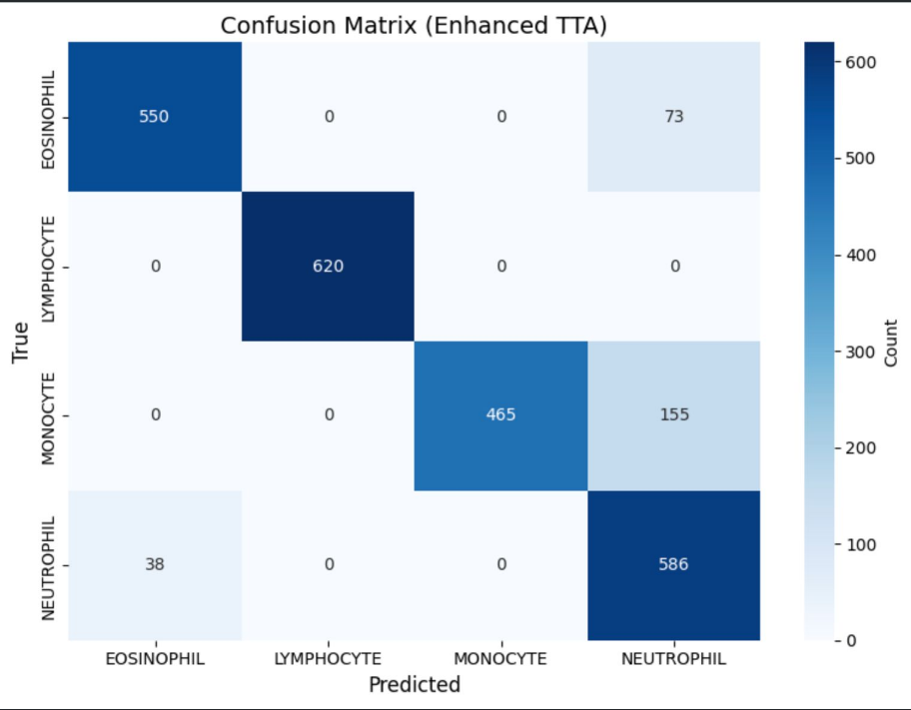

7. Conclusion: EfficientNet-B4 provides strong performance on most cell types.
Lymphocytes achieve perfect scores, Monocytes show high precision, and Neutrophils achieve significantly improved recall due to class weighting and TTA.

